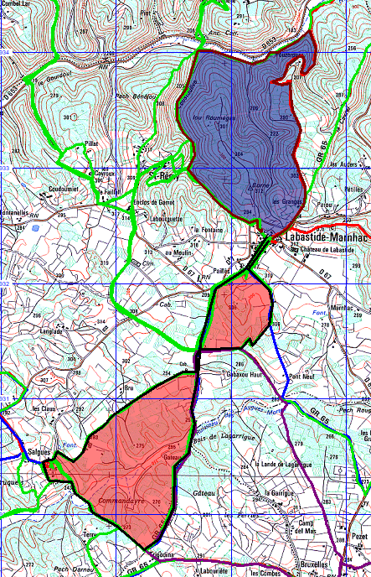
- Circuit Rouge via SALGUES 8km +-133m
- Circuit Bleu via St REMY 6km +-147m

