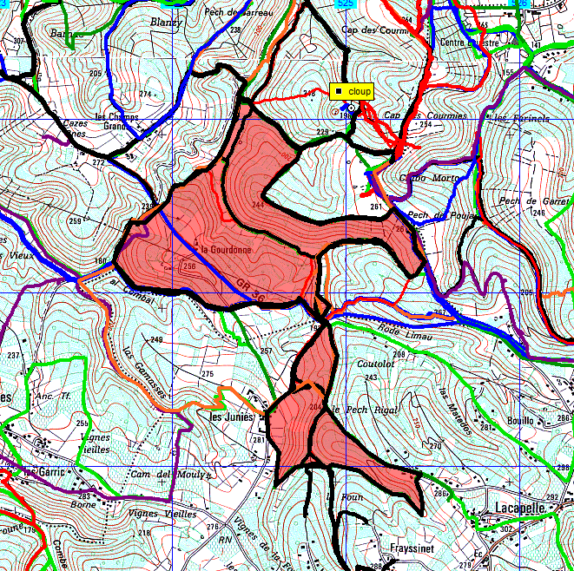Lacapelle 12km Pierrette

