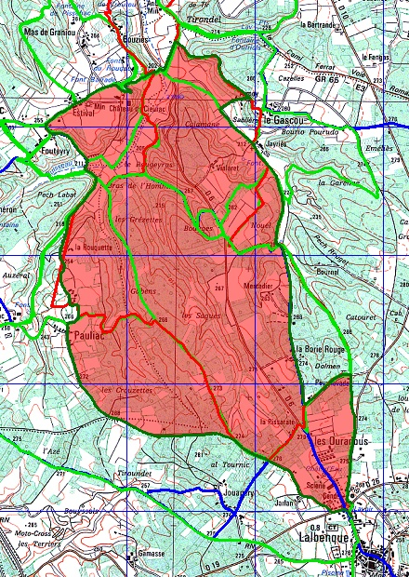
CIEURAC 11856 +-525m

